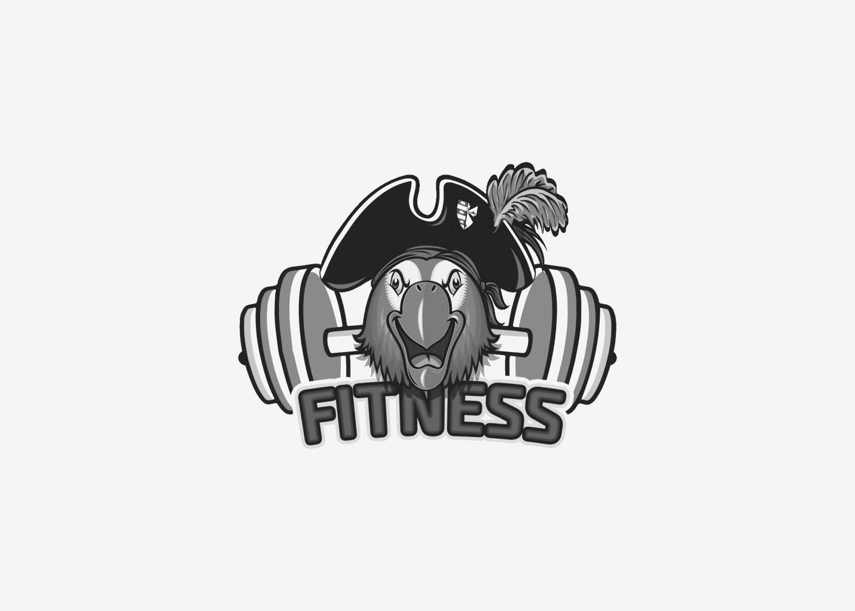
Barry University Fitness Center
Alumni Membership Application

Name: __________________________________________ Date: _____________________
Email: ____________________________________________Graduation Date:
Membership Type: Circle One
Option #1 = $90/semester (4 months)
Option #2 = $200/year

Start Date: _____________ End Date: ___________________ (For office use)
Payment:
Check #:___________ *Check made payable: Barry University
Amount:___________

*All members must adhere to the Barry University Fitness Center Rules & Regulations. Failure to abide may result in suspension or termination agreement without a refund. Member also understands that membership ONLY allows access to the Landon Fitness Center. Tennis courts, athletic courts/field, pool, Miller Studio are not included with this membership. Hours of operation may vary and are subject to the discretion of the Fitness Director and Barry University.
Member Signature: ___________________________________________ Date: ____________
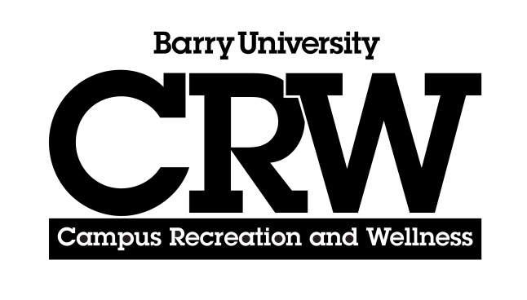
Application approved by: ______________________________________ Date: _____________

