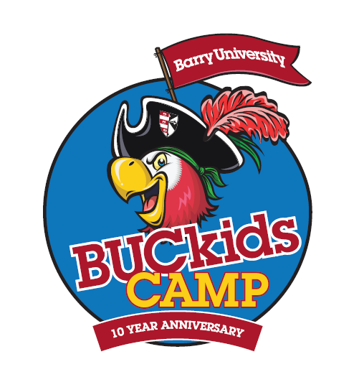
Camp Dates: 6/8/15 -7/31/15(M-F)
Camp Hours: 8:00am - 6:00pm
Camp Hotline: 305-899-3063
Week1: 6/8-6/12 Week5: 7/6-7/10
Week2: 6/15-6/19 Week6: 7/13-7/17
Week3: 6/22-6/26 Week7: 7/20-7/24
Week4: 6/29-7/2 Week8: 7/27-7/31
Week1: 6/9-6/13
Week1: 6/9-6/13
Week1: 6/9-6/13

SPECIAL EVENTS & ACTIVITIES

Date | Activity | Location
(M) June 8 | Words of Wisdom: RESPECT | Camp Headquarters
(W) June 10 | Wacky Wednesday: Hat/Cap Day | Camp Headquarters
(F) June 12 | Shipwreck Cove Waterpark | Miami Shores Aquatic Center
(M) June 15 | Words of Wisdom: HONESTY | Camp Headquarters
(W) June 17 | Wacky Wednesday: Sports Jersey Day | Camp Headquarters
 | Freedom Night (6pm-9pm) | Camp Headquarters
(F) June 19 | Bucky’s Carnival | Barry U (Athletic Fields)
(M) June 22 | Words of Wisdom: RESPONSIBILITY | Camp Headquarters
(W) June 24 | Wacky Wednesday: Crazy Costume Day | Camp Headquarters
(F) June 26 | Shipwreck Cove Waterpark | Miami Shores Aquatic Center
(M) June 29 | Words of Wisdom: KINDNESS | Camp Headquarters
(W) July 1 | Wacky Wednesday: Patriot Day | Camp Headquarters
 | Freedom Night (6pm-9pm) | Camp Headquarters
(F) July 3 | CAMP CLOSED | CAMP CLOSED
(M) July 6 | Words of Wisdom: PATIENCE | Camp Headquarters
(W) July 8 | Wacky Wednesday: Super Hero Day | Camp Headquarters
(F) July 10 | Groovy Movie / Community Service | Flippers Cinema/ Barry U
(M) July 13 | Words of Wisdom: SHARING | Camp Headquarters
(W) July 15 | Wacky Wednesday: Crazy Colors Day | Camp Headquarters
 | Freedom Night (6pm-9pm) | Camp Headquarters
(F) July 17 | Freedom Day/Birthday Bash | Barry U
(M) July 20 | Words of Wisdom: ORGANIZATION | Camp Headquarters
(W) July 22 | Wacky Wednesday: Pajama Day | Camp Headquarters
(F) July 24 | Shipwreck Cove Waterpark/ Boat Float | Miami Shores/ Barry U
 | Freedom Night (6pm-9pm) | Camp Headquarters
(M) July 27 | Words of Wisdom: LEADERSHIP | Camp Headquarters
(W) July 29 | Wacky Wednesday: Reverse Day | Camp Headquarters
(TH) July 30 | CAMP SHOW | Barry U (Broad Auditorium)
(F) July 31 | End of Camp Extravaganza | Barry U

