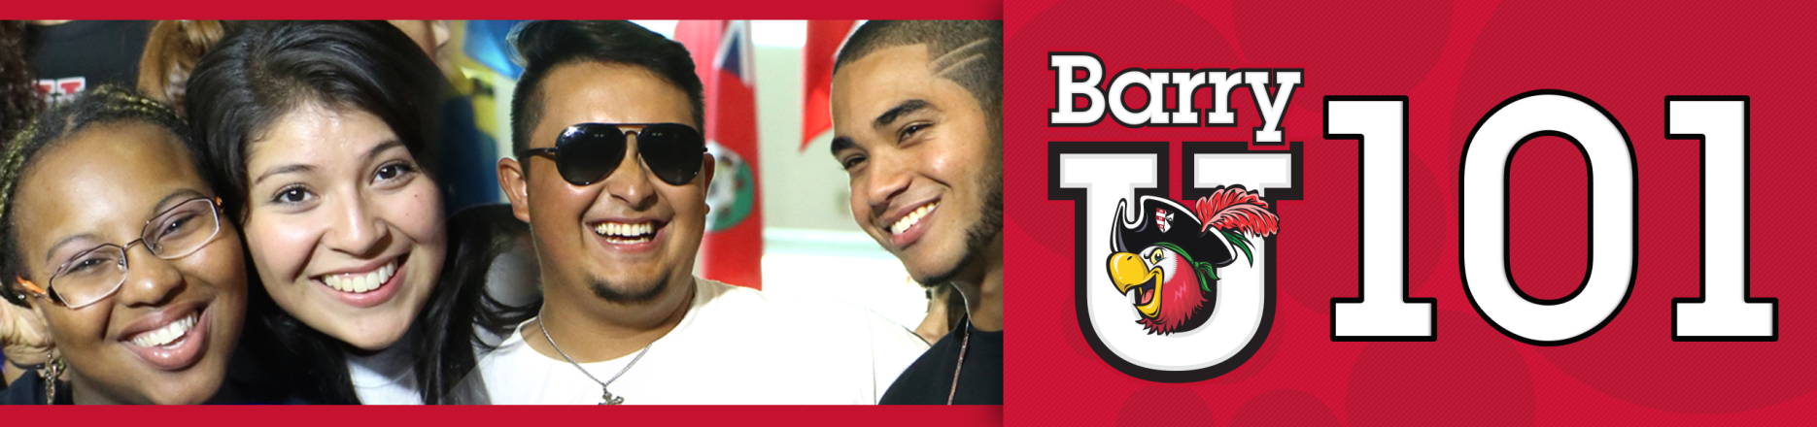
Freshmen Family & Guests Schedule
*The New Student BarryU 101Schedule may be subject to change
June 27th, 2016

7:00am-8:30am BarryU 101 Check-In for all Family & Guests HSC Gym

8:30am BarryU 101 Overview Landon Student Union

9:00am-4:00pm Hospitality Lounge (Refresh & Recharge) Commuter Lounge
Coffee, Tea, Light Snacks, Phone/ Electronic Charging Stations, (Landon 109)
Resources, and Newspaper
9:00am Welcome! Bienvenidos! Bienveni! Broad Auditorium
9:30am Campus Resources Panel Landon Events Room

10:00am Matt Cameron & Dr. Maria Alvarez Landon Events Room
10:30am Learning Center & Academic Resources Landon Events Room
11:00am Money Matters$$$!!!!! Landon Events Room
(Financial Aid & Cashier/Business Office)

12:00pm Parents Lunch Weber Grand Hall
1:00pm Student Life Landon Events Room
(Vice President of Student Affairs & Dean of Students)

1:30pm All about Academics! Academic ABC’s Broad Auditorium

2:00pm-4:30pm Campus Tours Landon 109
Tours pick-up from the Commuter Lounge (Landon 109)

2:00pm I’m First - First Generation College Student Landon Events Room

2:00pm Find Your Niche! School and Major Meetings:
Arts & Sciences Broad Auditorium
Human Performance & Leisure Sciences HSC 111
Health Sciences SNHS 222
Nursing Weigand 116W
Business Andreas 110
Education Powers 143 C
Social Work Powers 106

2:30pm-6:00pm Learn the Ropes… Academic Advising Various Locations

2:30pm-6:00pm Tests? Already? Challenge/Placement Testing Library Classroom 144
2:30pm-6:00pm Get it Done! Registration for Classes Andreas 111

2:30pm-6:00pm Feedback! BarryU 101Survey & Snacks Andreas 112

5:00pm – 6:00pm Time to Eat! Roussell Dining Hall

6:00pm Residence Life Meeting Thompson 230
(Mandatory for those living on campus)
Drive Time Show - Commuter Meeting
(For Commuters Only)

7:00pm – 8:00pm Parent Dessert Reception Bucky’s Cove

June 28th, 2016
7:00am – 9:00am Time to Eat! Breakfast Roussell Dining Hall
8:30am – 12:00pm Tests? Already? Early Challenge/ Placement Testing Library Classroom 144

9:00am-1:00pm Hospitality Lounge (Refresh & Recharge) Commuter Lounge
Coffee, Tea, Light Snacks, Phone/ Electronic Charging Stations, (Landon 109)
Resources, and Newspaper

9:00pm-12:00pm Learn the Ropes… Academic Advising Various Locations

8:30am -12:00pm Get it Done! Registration for Classes Andreas 111
10:30am-1:00pm Feedback! BarryU 101Survey & Snacks Andreas 112
(Candy & Popcorn Bar)
1:00pm – 5:00pm Check-Out …Return Room Keys & Meal Cards D&D and Weber Hall (Front Desk)

