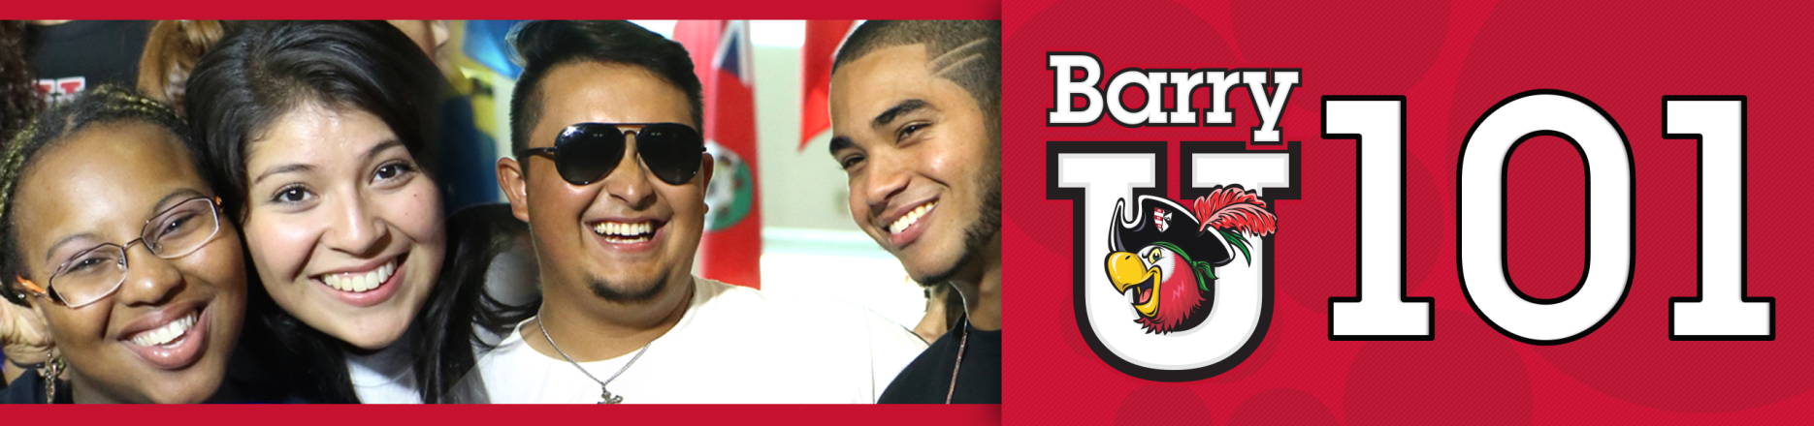
Freshmen Family & Guests Schedule
*The New Student BarryU 101Schedule may be subject to change

Monday, July 11th, 2016

7:00am -8:30am BarryU 101 Check-In for all Family& Guests HSC Gym

8:30am BarryU 101 Overview Landon Student Union
(Landon Events Room)
9:00am Welcome! Bienvenidos! Bienveni! Broad Auditorium
9:30am Campus Resources Panel Landon Events Room

10:00am Matt Cameron & Dr. Alvarez Landon Events Room

10:30am Learning Center & Academic Resources Landon Events Room

11:00am Money Matters$$$!!!!! Landon Events Room
(Financial Aid & Cashier/Business Office)

12:00pm Parents Lunch Weber Grand Hall
1:00pm Student Life Landon Events Room
(Vice President of Student Affairs & Dean of Students)

1:30pm All about Academics! Academic ABC’s Broad Auditorium

2:00pm-4:30pm Campus Tours
Tours pick-up from the Commuter Lounge (Landon 109)

2:00pm I’m First - First Generation College Student Landon Events Room
(Landon Events Room)
2:00pm Find Your Niche! School and Major Meetings:
Arts & Sciences Broad Auditorium
Human Performance & LeisureSciences HSC 111
Health Sciences SNHS 222
Nursing Weigand 116W
Business Andreas 110
Education Powers 143 C
Social Work Powers 106

2:30pm-6:00pm Learn the Ropes… Academic Advising Various Locations

2:30pm-6:00pm Tests? Already? Challenge/Placement Testing Library Classroom 144
2:30pm-6:00pm Get it Done! Registration for Classes Andreas 111

2:30pm-6:00pm Feedback! BarryU 101Survey & Snacks Andreas 112

6:00pm Residence Life Meeting Thompson 230
(Mandatory for those lving on campus)
Drive Time Show - Commuter Meeting Library
(For Commuters Only)

