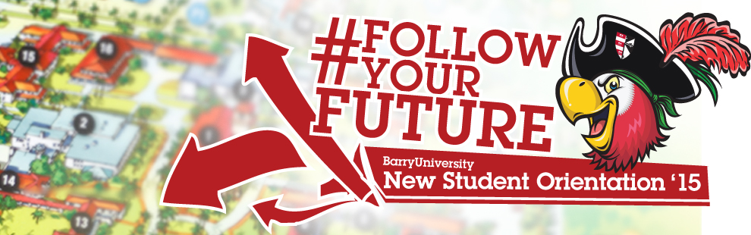
New Student Orientation – Freshmen Schedule
June 29th & 30th
*The New Student Orientation Schedule may be subject to change

Day One: June 29, 2015

7:00am-8:30am Orientation Check-In for all New Students HSC Gymnasium
*Continental Breakfast
*Check-in to Residence Hall Rooms if staying on Campus

7:00am – 9:00am Campus Connections & Resources Fair HSC Gymnasium
(includes continental Breakfast)

7:00am-9:00am Financial Questions? HSC Gymnasium
Financial Aid & Cashier / Business Office (7:00am-9:00am)

7:00am-9:00am Tests? Already? Early Challenge/ Placement Testing Library Classroom 144
8:00am Follow the leader! Meet your Orientation Leaders Various Locations and go through the Orientation Overview
8:30am Commuter Drive Time Show Thompson 230
(mandatory for commuter students)

9:00am Welcome! Bienvenidos! Bienveni! Broad Auditorium

9:30am What is BU? The Mission Broad Auditorium
10:00am – 10:45am Decisions, Decisions! (Making Good Choices) Broad Auditorium
10:45am – 11:15am Campus Resource Panel Broad Auditorium
11:15am – 12:00pm Money Matters$$$!!! Broad Auditorium
Financial Aid & Cashier / Business Office 12:00pm – 1:00pm Time to Eat! Lunch HSC Gymnasium
1:00pm – 3:00pm Information Technology Garner TBA
3:00pm – 3:30pm First Year Experience Programs Broad Auditorium
3:30pm – 4:00pm Learning Center Resources Broad Auditorium
4:00pm – 5:00pm Orientation Leader Time! Various Locations
4:00pm New Athletes Meeting Landon Events Room
(Only for Athletes)
5:00pm Housing& Residential Life Meeting Broad Auditorium
(mandatory for all students living on-campus)
6:00pm – 7:00pm Chartwells’ Miami BBQ Landon Courtyard
7:00pm - 10:00pm Evening Social Activities Various Locations
Speed Meeting & Ice Cream Social Broad Auditorium
Pool Party Penafort Pool

Day Two: June 30, 2015

6:30am – 9:00am Time to Eat! Breakfast HSC Gymnasium
7:00am – 10:00am Tests? Already? Challenge/Placement Testing Library Classroom 144
9:00am Follow the Leader! Meet w/ Orientation Leaders Various Locations
9:30am ORI 100 Presentation Broad Auditorium
10:00am Learning Communities Broad Auditorium
11:00am – 5:00pm Financial Questions? Andreas 111
Financial Aid & Cashier / Business Office
11:00am All About Academics! Academic ABC’s Broad Auditorium
11:30am Find Your Niche! School and Major Meetings:
Arts & Sciences Broad Auditorium
Human Performance & Leisure HSC 1
Health Sciences SNHS 222
Nursing Weigand 116E
Business Andreas 110
Education Powers 143 C
Social Work Powers 106
12:00pm - 2:30pm Tests? Already? Early Challenge/ Placement Testing Library Classroom 144
(Pick up Challenge and Placement Test Results)
12:00pm - 4:30pm Learn the Ropes… Academic Advising Various Locations

12:00pm-5:00pm Get it Done! Registration for Classes Andreas 111

12:00pm – 2:00pm Time to Eat! Lunch HSC Gymnasium

1:00pm-5:00pm Feedback! Orientation Survey & Snacks Andreas 112
(Candy & Popcorn Bar)

1:00pm – 5:00pm Check-Out …Return Room Keys & Meal Cards D&D and Weber Hall (Front Desk)

