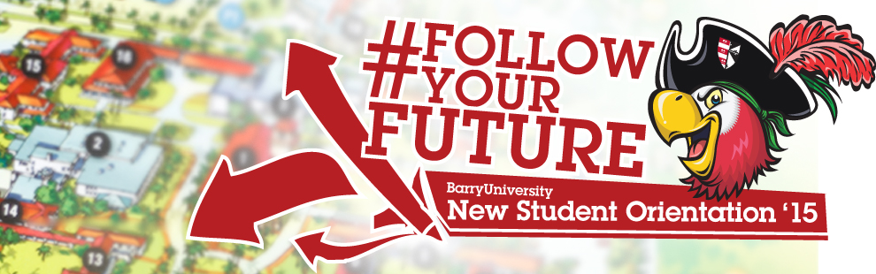
New Student Orientation - Transfer Schedule
*The New Student Orientation Schedule may be subject to change

Wednesday, August 19th, 2015:

10:00am-4:00pm Move-in (All Freshmen/ Transfer Resident Students) Landon Student Union
Orientation Check-In (Bucky’s Cove/Landon Events Room)

11:00am-2:00pm Campus Tours (Optional) Depart from Landon 109 *Designated Times: 11:00am, 12:00pm, 1:00pm & 2:00pm

12:00pm – 4:00pm Resource Fair! HSC Gymnasium

1:00pm-5:00pm Publix & Target Trips (Optional) Landon Atrium *Designated Times: 1:00pm, 2:00pm, 3:00pm & 4:00pm

Walmart Trips (Optional) Landon Atrium
*Designated Times: 1:00pm, 2:30pm, & 4:00pm

4:30pm Housing & Residence Life Meeting Broad Auditorium
* Mandatory for all students living on campus

5:00pm Hall Meetings Various Locations
* Mandatory for all students living on campus

6:00pm – 6:45pm Time to Eat! Dinner Dominican Lawn

6:45pm Speed Meeting & Ice Cream Social! Dominican Hall Field

7:00pm Pre-Game Bash!! Soccer Field
(Women’s Soccer Game vs. Johnson & Wales)

Thursday, August 20th, 2015:

6:00am-8:30am Orientation Check-In for all New Students HSC Gymnasium
*Continental Breakfast
* Only for students who have not checked in yet

6:30am Follow the Leader! Meet your Orientation Leaders Various Locations
*Only for students who are required to take placement testing

7:00am – 9:00am Campus Connections & Resources Fair HSC Gymnasium

7:00am-6:00pm Financial Questions? HSC Gymnasium
(7:00am-9:00am)
Financial Aid & Cashier / Business Office Andreas 111
(2:00pm-6:00pm)
7:00am-9:00am Tests? Already? Early Challenge/ Placement Testing Library Classroom 144
8:00am Meet Your Orientation Leader! Various Locations
Orientation Overview
*Only for students who are NOT required to take placement testing

8:30am Drive Time Show - Commuter Meeting Broad Auditorium

9:00am Welcome! Bienvenidos! Bienveni! Broad Auditorium

9:30am What is BU? The Mission Broad Auditorium
10:00am - 11:00am Money Matters$$$!!! Thompson 230
Financial Aid & Cashier / Business Office

11:00am – 12:00pm Information Technology Garner (TBA)

12:00pm – 1:00pm Time to Eat! Lunch Roussell Dining Hall
1:00pm – 1:30pm Career Connections! Get eBUC$ Broad Auditorium
1:30pm All about Academics! Academic ABC’s Broad Auditorium
2:00pm Find Your Niche! School and Major Meetings:
Arts & Sciences Broad Auditorium
Human Performance & Leisure HSC 1
Health Sciences SNHS 222
Nursing Weigand 249
Business Andreas 110
Education Powers 143 C
Social Work Powers 106

2:30pm- 5:00pm Tests? Already? Early Challenge/ Placement Testing Library Classroom 144
(Pick up Challenge and Placement Test Results)
3:00pm-6:00pm Learn the Ropes… Academic Advising Various Locations

3:00pm-6:00pm Get it Done! Registration for Classes Andreas 111

3:00pm-6:00pm Feedback! Orientation Survey & Snacks Andreas 112
(Candy & Popcorn Bar)

3:00pm-5:00pm Campus Tours Leaving from Landon 109
(*registration must be completed prior to taking a tour)

5:00pm New Athletes Meeting Landon Events Room
(For Athletes Only)

5:00pm – 7:00pm Soup’s On! Dinner Roussell Dining Hall

6:30pm – 10:00pm Miami Bus Tour Various Miami Locations
*Spaces are limited sign-up at the
Hospitality Desk / Commuter Lounge
Stopping at Bayside and Lincoln Road (South Beach)

9:00pm – 11:00pm Movie & Pizza Social Landon Events Room

