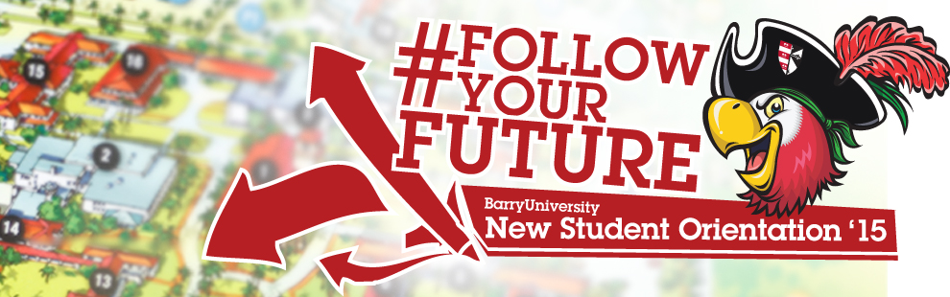
Family & Guests Schedule - Transfer Orientation

Wednesday, August 19th, 2015:

10:00am-4:00pm Move-in (All Freshmen/ Transfer Resident Students) Landon Student Union
Orientation Check-In (Bucky’s Cove/Landon Events Room)

10:00am-4:00pm Orientation Check-In for all Family & Guests Landon Student Union

11:00am-2:00pm Campus Tours (Optional) Depart from Landon 109 *Designated Times: 11:00am, 12:00pm, 1:00pm & 2:00pm

12:00pm – 4:00pm Resource Fair! HSC Gymnasium

1:00pm-5:00pm Publix & Target Trips (Optional) Landon Atrium *Designated Times: 1:00pm, 2:00pm, 3:00pm & 4:00pm

Walmart Trips (Optional) Landon Atrium
*Designated Times: 1:00pm, 2:30pm, & 4:00pm

4:30pm Housing & Residence Life Meeting Broad Auditorium
* Mandatory for all students living on campus

6:00pm – 7:00pm Time to Eat! Dinner Dominican Lawn

7:00pm Family & Guest Dessert Reception HSC Gymnasium

August, 20th, 2015

6:00am – 7:00am Continental Breakfast HSC Gymnasium

7:00am-8:30am Orientation Check-In for all Family & Guests HSC Gymnasium

7:00am-9:00am Campus Connections & Resources Fair HSC Gymnasium
(Includes continental breakfast)

7:00am-6:00pm Financial Questions? HSC Gymnasium
(7:00am-9:00am)
Financial Aid & Cashier/ Business Office Andreas 111
(2:00pm-6:00pm)

8:00am-4:00pm Hospitality Lounge (Refresh & Recharge) Commuter Lounge
Coffee, Tea, Light Snacks, Phone/ Electronic Charging Stations, (Landon 109)
Resources, and Newspaper
8:00am Meet Your Orientation Leader! Landon Events Room

8:30am Orientation Overview Landon Events Room
9:00am Welcome! Bienvenidos! Bienveni! Broad Auditorium

9:30am What is BU? The Mission Broad Auditorium
10:00am-11:00am Campus Resources Panel Landon Events Room
11:00am-11:30am Student Resource Panel Landon Events Room
11:30am- 12:00pm Learning Center & Academic Resources Landon Events Room
12:00pm-12:45pm Family & Guest Lunch HSC Gymnasium
1:00pm-1:30pm Student Life Landon Events Room
(Vice President of Student Affairs & Dean of Students)
1:30pm – 2:30pm Money Matters$$!!! Landon Events Room
2:30pm-5:00pm Campus Tours Landon 109 (Tours pick-up from Commuter Lounge)

3:00pm-5:00pm Feedback! Orientation Survey & Snacks Andreas 112
(Candy & Popcorn Bar)
*Parents, Family, and Guests are free to depart at any time

5:00pm – 7:00pm Soup’s On! Dinner Roussell Dining Hall

6:30pm – 10:00pm Miami Bus Tour Various Miami Locations
*Spaces are limited sign-up at the
Hospitality Desk / Commuter Lounge
Stopping at Bayside and Lincoln Road (South Beach)

