Rotation # | Dates |  | EOR
1 | August 21, 2017 | September 26, 2017 | September 27, 28, 29, 2017
2 | October 2, 2017 | November 7, 2017 | November 8, 9, 10, 2017
3 | November 13, 2017 | January 5, 2018 | January MON 8 & TUES 9, 2018
Days off rotation: Thanksgiving Break November 20-24, 2017
Holiday Break December 24, 2017 - January 1, 2018

4 | WED January 10, 2018 | February 14, 2018 | February THURS 15 & FRI 16, 2018
5 | February 19, 2018 | March 26, 2018 | March TUES 27 WED 28  Days off: March 29-30, 2018
6 | April 2, 2018 | May 8, 2018 | May 9, 10, 11, 2018
Days off rotation: Semester Break May 14-28, 2018
{AAPA Conference May 19-23, 2018 New Orleans}

7 | May 29, 2018 | July 6, 2018 | July MON 9 TUES 10, 2018
8 | WED July 11, 2018 | August 17, 2018 | Aug 29, 30, 31, 2018
Days off before EOR 8: Break August 20-28, 2018
Advanced didactic semester begins the week of September 3, 2018

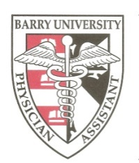
Barry University
Physician Assistant Program
Clinical Rotation Schedule for Class of 2018

