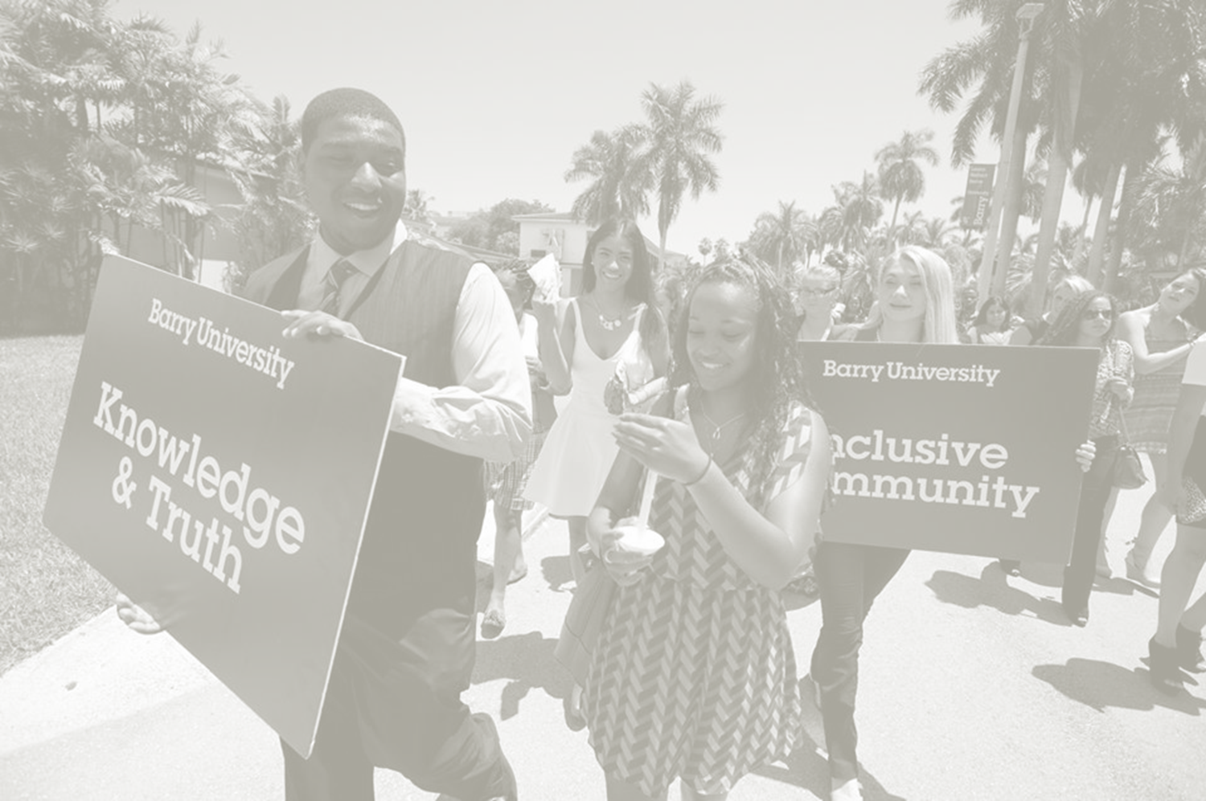
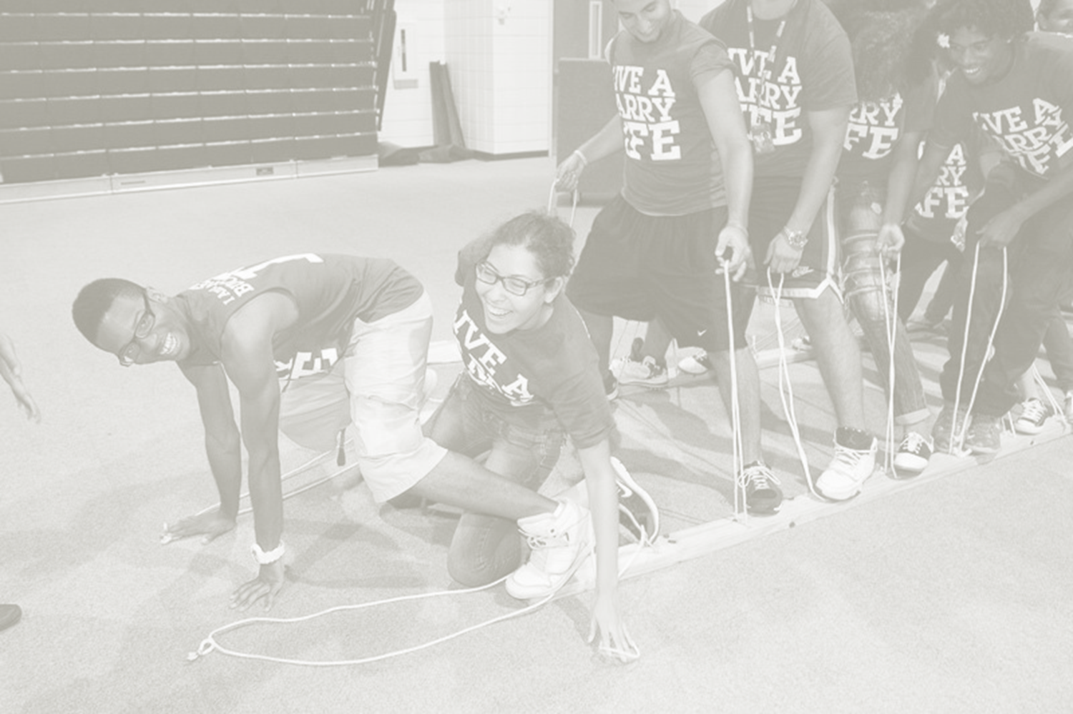
Student Leadership Selection Process & Application
How can I become a student leader?
Find out all you can about the student leader positions! You’ve already taken the first step by inquiring and receiving an application. Don’t stop there. Attend one of the Student Leader Information Sessions. Ask questions! The more people you speak with, the better you’ll understand the jobs and what it’s really like to be a student leader.
WHY become a student leader?
- Make the Barry community more vibrant and spread the word that “there is something to do!”
- Have the opportunity to make a difference and establish yourself as a strong campus leader.
- Have an opportunity to work for social justice in your community.
- Enhance your résumé with leadership skills such as communication, and hands-on experiences.
- Be a part of a team that makes activities and events happen on campus.
- Get to meet new people and build lasting relationships with other students
- Get to meet and interact with performers and say, “I knew them before they were big!”
- Possibility of attending conferences and retreats to learn from professionals and students working with similar programs.
- Gain valuable experience in event planning, marketing, implementation, and assessment.
- Have fun!
Conditions of Student Leadership
Minimum Eligibility Requirements:
- All applicants must have, and maintain, a cumulative GPA of at least a 2.5.
- All applicants must have at least 12 semester hours of college course-work completed, preferably at Barry.
- Applicants must not be on University Probation before or for the duration of their term in any position.
- Applicants must be full-time enrolled students.
- Recommendation forms from two current Barry University faculty or staff members must be completed and submitted (student and/or peer recommendations are not acceptable).
- Applicants must answer ALL questions on the application.
PLEASE NOTE:
FOR AN APPLICATION TO BE CONSIDERED, ALL PARTS OF THE APPLICATION, INCLUDING RECOMMENDATION FORMS, MUST BE SUBMITTED TO THE CENTER FOR STUDENT INVOLVEMENT
(Landon Student Union, 108)
BY 5:OOPM ON March 15, 2016.

The Application
Applications will be available on the http://www.barry.edu/student-involvement/student-organizations/forms.html and on the Student Web and are due March 15, 2016 by 5pm in the Center for Student Involvement. Please complete and submit the application and solicit two recommendations. Letters of recommendation may be sent directly to the De Porres Center for Ethical Leadership, Landon 108, scan and send it to sramos@barry.edu, or fax to 305-899-3676.
The Announcement
Selection notifications will be emailed through Barry “mymail” email accounts on
Friday, March 18th, 2016.
The Carousel
The Student Leader Carousel is a group interviewing process and is scheduled for
Monday, March 21, 2016, 3:00PM - 7:00PM Registration in Landon 202.
The Interview
Tuesday, March 22, 2016, 3:00PM - 7:00PM in Landon Events Room
Interviews will be conducted by invitation only with an interview team.
Want more Info?
Thank you for your interest in the Y?U Student Leadership Process! If you have additional questions, please contact de Porres Center for Ethical Leadership, 305-899-2944.

The Résumé

All résumés must be reviewed and stamped by Career Development (Landon 205.) Students must complete a résumé utilizing the Résumé Critique Checklist to properly prepare one’s resume before the résumé is critiqued. A follow up appointment with a Career Counselor may be needed.

Resume Critique Checklist
FORMAT
- Template (Resume templates should not be utilized. They are generic and do not impress employers). ____
- Font (Resumes should have 10-12 point font, Ariel or Times New Roman; Name should be larger). ____
- Margins (Margins should be between 0.5 and 1.0 inches all around). ____
- Each section is in reverse chronological order so that most recent activity is first. ____
- Full sentences are not used (pronouns such as I, my, or me are not needed). ____
- Bulleted descriptions (Paragraphs are too long and will not be read by a busy employer). ____
- Single Page (Resumes should be one page unless exceptions are made due to experience). ____
- Spelling and grammatical errors should not exist. ____

SUMMARY OF QUALIFICATIONS OR OBJECTIVE
- Summary highlights skills and accomplishments relevant to the position being applied for,
in fully described statements. ____
- If using an objective, it must be tailored and specific and state how you will impact
the organization that you are applying to. ____
- Either an objective or summary of qualifications is used, not both. ____

EDUCATION
- Includes institution, location (city, state), major, minor, and graduation date (month/year)
*Education may also include GPA, study abroad if appropriate, and relevant coursework ____
EXPERIENCE SECTION(S)
- Includes full-time, part-time, and internship opportunities (or these are broken out into
separate categories including but not limited to Related Experience, (Industry) Experience, Leadership Experience, etc. ____
- Includes Name of Organization, position, location (city/state), and dates employed (month/year)____
- Descriptions of experience use action verbs and/or buzz words ____
- Explain how you completed tasks/what you accomplished in descriptive statements ____
- Campus activities and community involvement/volunteering relates to the focus of the resume. ____
- If officer positions are held, leadership role is described and quantified. ____
- Academic projects, related coursework and/or lab experience used to expand section ____
HONORS/AWARDS/PROFESSIONAL DEVELOPMENT
- Lists the name, type of award, and date received ____
- Lists conferences attended and/or professional affiliations/associations/memberships ____

REFERENCES
- References are not included on the resume (should be listed on a separate document with matching header) ____

Student Leader Positions

BARRY UNIVERISTY STUDENT ALUMNI ASSOCIATION (BUSAA)
Our mission is to prepare future graduates for a life after commencement enriched with personal and professional skills, connections, and experiences, as well as an everlasting bond with their alma mater developed through interactions with Barry University students, faculty, staff, and most importantly—our Alumni. BUSAA vows to further enhance the affinity relationship between Barry University and its future graduates, by instilling a sense of pride and community amongst the current student body and constituency of Alumni.
CAMPUS ACTIVITIES BOARD (CAB)
CAB has positions open to all Barry University students and plans, coordinates and presents many of the campus-wide events for students at Barry. By utilizing students’ talents and energies, CAB strives to provide dynamic and diverse programs that meet the needs and interests of all students at Barry. We strive for excellence among our members and in our sponsored events.
COMMUTER ASSISTANT The Commuter Assistant’s Program, will be an opportunity for “seasoned” student volunteers to be paired with incoming commuter students to provide support, advice, and camaraderie during the new students’ first year. Commuter Assistants (CAs) work hard to ensure that new commuter students adjust to life at Barry University and have positive and constructive college experiences. This will also be a chance to help with events and activities for Commuter Student Resources.
First Year Experience Ambassador (FYEA)
FYEA are a select group of student leaders dedicated to serving first-year student by helping students navigate the transition in to the Barry University community; providing support, leadership, advice and helping new students connect to the university faculty, staff and services.

INTERNATIONAL AMBASSADOR (IA)
An International Ambassador is a full-time student who actively volunteers his/her time and energy to help new international freshman and transfer students assimilate and acculturate, adjusting to Barry University and the United States.
National Society for Leadership and Success (Must have a 3.0 GPA)
The Society is the nation's largest leadership honor society. Students are selected by their college for membership based on either academic standing or leadership potential. Candidacy is a nationally recognized achievement of honorable distinction. With 491 chapters, the Society currently has 524,519 members nationwide.
In addition to honorable distinction, the Society provides a step-by-step program for members to build their leadership skills through participation at their campus or online. Upon completion of the program, members receive their leadership certificate and take their place among the top student leaders at their campus and across the country.

ORIENTATION TEAM (O-Team)
Orientation Team (O-Team) members are students who want to make significant contributions to Barry University by assisting new students and their families. Team members will support the development and implementation of first-year student Orientation programs, including spring, summer and fall Orientations, assisting new students and their families in transitioning into the Barry community. O-Team members will have opportunities to improve self-confidence, communication skills and leadership abilities, as well as become the most informed students on-campus who are high energy, close-knit, and dynamic. Ideal candidates will be energetic, possess strong communication skills, and can work well individually and as part of a team.

STUDENT GOVERNMENT ASSOCIATION (SGA)
Student Government gives every undergraduate student the chance to practice and develop leadership skills while representing their peers and improving the University and student life. Students involved in Student Government have the chance to interact with the University administration and faculty and work in a collaborative manner to better Barry University. Student Government members are respected as leaders of the student body, and their input is often sought in making important decisions for the University.
STUDENT AMBASSADORS
Student Ambassadors represent an integral part of the University’s admissions process. They provide a vital link for future student leaders who strive to attend Barry University to further their educations. The Student Ambassadors are comprised of an elite group of domestic and international students who represent various cultures, creeds and religions. Through their diversity, education and experiences, they promote leadership, friendship and understanding throughout the depths of the Barry community.

Student Organization Council (SOC)
The Student Organization Council (SOC) acts as the advocate for all registered and recognized clubs and organizations. Student Organization Council believes that clubs and organizations are the life of the campus and an individual’s decision to get involved is essential to truly enjoying their college years. To ensure that student involvement in a club or organization is a rewarding experience SOC will provide leadership opportunities, strive to develop a spirit of unity, and represent the interest of all organizations while catering to the needs of all student leaders. Additionally, SOC will assist organizations and help them to remain in good standing with the council, as well as encourage interaction and communication among organizations and students to increase awareness of the clubs and organizations at Barry University.

Student Leader Application 2016
Full Name _________________________________________________________________________________________________________________
(Last) (First) (M.I.)

Student ID #: ___________________________________ E-mail Address: ______________________________________________________
Campus/Local Address: __________________________________________________________________________________________________
Street City State Zip Code

Permanent/Home Address (where you will be this summer):

______________________________________________________________________________________________________________________________
Street City State Zip Code

Home Phone: _________________________________ Cell Phone: ______________________________
Classification (please circle one):
Freshman Sophomore Junior Senior Graduate
Major(s): ________________________________________ Minor(s): _______________________________________________
Anticipated date of Graduation (semester/year): ___________________________________
Cumulative GPA: __________________ (If you’re a freshman, please put your high school GPA)
Previous semester GPA: __________ TOTAL CREDITS TAKEN_____________________________
Applicants will not be processed without two recommendations. Recommendations forms may be faxed (305-899-3676) or emailed to rfellinger@barry.edu. Due date: March 15, 2016 by 5pm.
Reference Name: __________________________________ Phone: _________________________________________
Reference Name: __________________________________ Phone: _________________________________________
ESSAY QUESTION
On a separate sheet(s) please answer the following questions as briefly and concisely as possible. Pease type and limit your response(s) to no more than one page single-spaced.
- Why are you applying for a student leadership position? What would you gain from and give to the position?
- What do you think is the biggest need for Barry students today? How can you help meet that need?
- How does your answer to question #1relate to the Barry University Mission?
Please rank your organization preference/interest from 1-8 (i.e. 1 indicating highest interest):
___Campus Activities Board ___ International Ambassadors ___ Student Ambassadors
___ Orientation Team _ Student Government Association ___ BUSAA ___ Commuter Assistant ___ Community Assistant ___ NSLS
___ FYE Ambassadors __ Student Organization Council
Legal/ Release Information

The information supplied in this application is correct to the best of my knowledge and in compliance with Barry University’s Student handbook. I agree to comply with all requirements should I be offered and accept a position. I understand that intentionally providing any false information could result in the rejection of my application and/or rescinding of an offer of position. I also acknowledge that I wish to actively pursue a position as indicated on this application and authorize the person(s) conducting the selection process to obtain information about me as needed to verify my eligibility for such a position. I understand this includes, but is not limited to, authorizing Center for Student Involvement, and/or other related parties to access my academic records and judicial records. I understand and give permission to Center for Student Involvement to review my academic and judicial standing while I am in a student leadership position.

In addition, I understand that should I be appointed to this leadership position, I must attend all training sessions and scheduled meetings pertaining to this position. By making a commitment to one or more of these leadership positions, I understand that there are increased expectations for me. These include, but are not limited to, self-responsibility, peer accountability, and open communication with the appropriate staff members.

I understand that all documents related to this application including, but not limited to, signed reference forms are confidential. I further understand that I will not have the opportunity to personally review these documents if I have waived that right. However, I may meet with a member of the Center for Student Involvement Staff to obtain feedback. This procedure is in compliance with the Family Educational Rights and Privacy Act of 1974.

By signing this agreement, I understand that I may be removed from this process at any time by the Director of Center for Student Involvement, or designee. I also understand that I am in no way guaranteed a position regardless of my attendance to the application process events or classes.

Promoting an inclusive community is central to the mission of Barry University. Center for Student Involvement seeks individuals who are eager to join us in our commitment to recognize and support all students in the Barry community. Center for Student Involvement does not discriminate on the basis of race, religion, color, gender, age, sexual orientation, national or ethnic origin, veteran status, or disability.

Applicant’s Signature: _____________________________________ Date: ____________________

Recommendation Form
Student Leader Application 2016

NAME OF APPLICANT: ______________________________________________________________________________

References are an integral part of the Student Leader application process and no decision can be made without them. This form must be returned in a sealed envelope by the reference writer. The reference must be received by March 15, 2016 by 5pm in the Center for Student Involvement in order for the candidate to be considered for the position. Your prompt completion of this form is greatly appreciated.
Please return this form to:

De Porres Center for Ethical Leadership
11300 NE 2nd Avenue, Miami Shores, FL 33161
Recommendations forms may be faxed (305-899-3676) or email to sramos@barry.edu

APPLICANT (please choose one):
I waive my right to read this reference: ___________________________________________________________________
Signature

I do not waive my right to read this reference: ___________________________________________________________________
Signature
REFERENCE WRITER:
Name: ___________________________________________________________ Phone Number ______________________________________
Employer: ______________________________________________________ Title: ___________________________________________________
How long have you known the applicant? ______________________________________________________________________________
In what capacity? _________________________________________________________________________________________________________

Based on your observed knowledge, please evaluate the candidate in the following areas.

5 = Outstanding 4 = Above Average 3 = Satisfactory 2 = Below Average 1 = Unsatisfactory NB = No basis for rating

Administrative Ability | 5 | 4 | 3 | 2 | 1 | NB
Assertiveness | 5 | 4 | 3 | 2 | 1 | NB
Confidentiality | 5 | 4 | 3 | 2 | 1 | NB
Creativity | 5 | 4 | 3 | 2 | 1 | NB
Dependability | 5 | 4 | 3 | 2 | 1 | NB
Organization | 5 | 4 | 3 | 2 | 1 | NB
Maturity | 5 | 4 | 3 | 2 | 1 | NB
Resourcefulness | 5 | 4 | 3 | 2 | 1 | NB
Self-Confidence | 5 | 4 | 3 | 2 | 1 | NB
Establishing Trust | 5 | 4 | 3 | 2 | 1 | NB
Initiative | 5 | 4 | 3 | 2 | 1 | NB
Inter-Cultural Awareness | 5 | 4 | 3 | 2 | 1 | NB
Judgment | 5 | 4 | 3 | 2 | 1 | NB
Leadership | 5 | 4 | 3 | 2 | 1 | NB
Listening Skills | 5 | 4 | 3 | 2 | 1 | NB
Sensitivity | 5 | 4 | 3 | 2 | 1 | NB
Problem Solving | 5 | 4 | 3 | 2 | 1 | NB
Time Management | 5 | 4 | 3 | 2 | 1 | NB
Working as a Team Member | 5 | 4 | 3 | 2 | 1 | NB

Recommendation Form
Student Leader Application 2016

Please comment on the strengths of this candidate:

________________________________________________________________________________________________________________________________________________________________________________________________________________________________________________________________________________________________________________________________________________________________________________________________________________________________________________________________________________________________________________________________________________________________________________________________________________________________________________________________________________________________________________________________________________________________________________________________________________________________________________________________________________________________________________________________________________________________________________________________________________________________________________________________________________________________________________________________________________________________________________________________________________________________________________________________________________________________________________________________________________________________________________________________________________________________________________________________________________________________________________________________________________________________________________________________________________________________________________________________________________________________________________________________________________________________________________________________________________________________________________________________________________________________

Please comment on areas in which this candidate needs improvement:

____________________________________________________________________________________________________________________________________________________________________________________________________________________________________________________________________________________________________________________________________________________________________________________________________________________________________________________________________________________________________________________________________________________________________________________________________________________________________________________________________________________________________________________________________________________________________________________________________________________________________________________________________________________________________________________________________________________________________________________________________________________________________________________________________________________________________________________________________________________________________________________________________________________________________________________________________________________________________________________________________________________________________________________________________________________________________________________________________________________________________________________________________________________________________________________________________________________________________________________________________________________________________________________________________________________________________________________________________________________________________________________________________________________________________________________________________________________________________________________________________________________________________________________________________________________________________________________________________

Would you recommend this candidate for the Student Leader position?
_______Highly Recommend ______Recommend with reservations
_______Recommend ______Would not recommend at this time

Thank you for taking the time to participate in the
Spring 2016 Barry University Student Leader Selection Process
De Porres Center for Ethical Leadership
Recommendation Form
Student Leader Application 2016

NAME OF APPLICANT: ______________________________________________________________________________

References are an integral part of the Student Leader application process and no decision can be made without them. This form must be returned in a sealed envelope by the reference writer. The reference must be received by March 15, 2016 by 5pm in the Center for Student Involvement in order for the candidate to be considered for the position. Your prompt completion of this form is greatly appreciated.
Please return this form to:

De Porres Center for Ethical Leadership
11300 NE 2nd Avenue, Miami Shores, FL 33161
Recommendations forms may be faxed (305-899-3676) or email to sramos@barry.edu

APPLICANT (please choose one):
I waive my right to read this reference: ___________________________________________________________________
Signature

I do not waive my right to read this reference: ___________________________________________________________________
Signature
REFERENCE WRITER:
Name: ___________________________________________________________ Phone Number ______________________________________
Employer: ______________________________________________________ Title: ___________________________________________________
How long have you known the applicant? ______________________________________________________________________________
In what capacity? _________________________________________________________________________________________________________

Based on your observed knowledge, please evaluate the candidate in the following areas.

5 = Outstanding 4 = Above Average 3 = Satisfactory 2 = Below Average 1 = Unsatisfactory NB = No basis for rating

Administrative Ability | 5 | 4 | 3 | 2 | 1 | NB
Assertiveness | 5 | 4 | 3 | 2 | 1 | NB
Confidentiality | 5 | 4 | 3 | 2 | 1 | NB
Creativity | 5 | 4 | 3 | 2 | 1 | NB
Dependability | 5 | 4 | 3 | 2 | 1 | NB
Organization | 5 | 4 | 3 | 2 | 1 | NB
Maturity | 5 | 4 | 3 | 2 | 1 | NB
Resourcefulness | 5 | 4 | 3 | 2 | 1 | NB
Self-Confidence | 5 | 4 | 3 | 2 | 1 | NB
Establishing Trust | 5 | 4 | 3 | 2 | 1 | NB
Initiative | 5 | 4 | 3 | 2 | 1 | NB
Inter-Cultural Awareness | 5 | 4 | 3 | 2 | 1 | NB
Judgment | 5 | 4 | 3 | 2 | 1 | NB
Leadership | 5 | 4 | 3 | 2 | 1 | NB
Listening Skills | 5 | 4 | 3 | 2 | 1 | NB
Sensitivity | 5 | 4 | 3 | 2 | 1 | NB
Problem Solving | 5 | 4 | 3 | 2 | 1 | NB
Time Management | 5 | 4 | 3 | 2 | 1 | NB
Working as a Team Member | 5 | 4 | 3 | 2 | 1 | NB

Recommendation Form
Student Leader Application 2016

Please comment on the strengths of this candidate:

________________________________________________________________________________________________________________________________________________________________________________________________________________________________________________________________________________________________________________________________________________________________________________________________________________________________________________________________________________________________________________________________________________________________________________________________________________________________________________________________________________________________________________________________________________________________________________________________________________________________________________________________________________________________________________________________________________________________________________________________________________________________________________________________________________________________________________________________________________________________________________________________________________________________________________________________________________________________________________________________________________________________________________________________________________________________________________________________________________________________________________________________________________________________________________________________________________________________________________________________________________________________________________________________________________________________________________________________________________________________________________________________________________________________

Please comment on areas in which this candidate needs improvement:

____________________________________________________________________________________________________________________________________________________________________________________________________________________________________________________________________________________________________________________________________________________________________________________________________________________________________________________________________________________________________________________________________________________________________________________________________________________________________________________________________________________________________________________________________________________________________________________________________________________________________________________________________________________________________________________________________________________________________________________________________________________________________________________________________________________________________________________________________________________________________________________________________________________________________________________________________________________________________________________________________________________________________________________________________________________________________________________________________________________________________________________________________________________________________________________________________________________________________________________________________________________________________________________________________________________________________________________________________________________________________________________________________________________________________________________________________________________________________________________________________________________________________________________________________________________________________________________________________

Would you recommend this candidate for the Student Leader position?
_______Highly Recommend ______Recommend with reservations
_______Recommend ______Would not recommend at this time

Thank you for taking the time to participate in the
Spring 2016 Barry University Student Leader Selection Process
De Porres Center for Ethical Leadership

