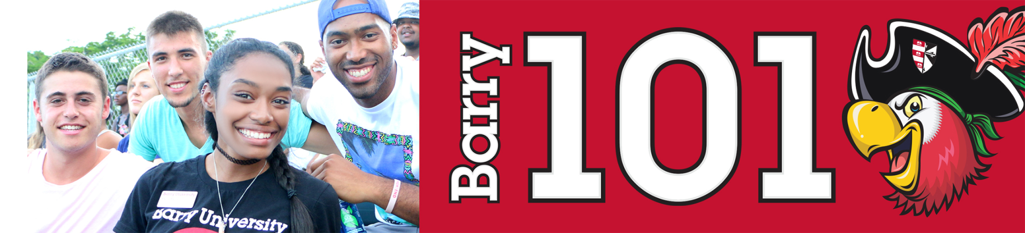
International Student Orientation
Thursday, August 18th, 2016:

6:00am-8:30am Orientation Check-In for all New Students HSC Gymnasium
*Continental Breakfast
* Only for students who have not checked in yet

6:30am Follow the Leader! Various Locations
Meet your Orientation Leaders
*Only for students who are required to take placement testing

7:00am – 9:00am Campus Connections & Resources Fair HSC Gymnasium

7:00am-6:00pm Financial Questions? HSC Gymnasium
(7:00am-9:00am)
Financial Aid & Cashier / Business Office Andreas 111
(2:00pm-6:00pm)
7:00am-9:00am Tests? Already? Library Classroom 144
Early Challenge/ Placement Testing

8:30am ORI 100 (Freshmen Only) Broad Auditorium

9:00am Welcome! Bienvenidos! Bienveni! Broad Auditorium

9:30am Barry Mission - Who Am I Called to Be Broad Auditorium

10:00am – 12:30pm International Student Orientation Thompson 230
Welcome – Dr. Smith, Vice President - Student Affairs
International & Multicultural Programs Slideshow
Resource Manual / Website Overview
Immigration 101 / J1 Information
Question & Answer Contest

12:30pm – 1:30pm Information Technology Garner Classroom (TBA)

1:30pm All about Academics! Academic ABC’s Broad Auditorium

2:00pm Find Your Niche! School and Major Meetings:
Arts & Sciences Broad Auditorium
Human Performance & Leisure Scineces HSC 1
Health Sciences SNHS 222
Nursing Weigand 116E
Business Andreas 110
Education Powers 143 C
Social Work Powers 106

2:30pm – 6:00pm Tests? Already? Library Classroom 144
Early Challenge/ Placement Testing

2:30pm-6:00pm Learn the Ropes… Academic Advising Various Locations

2:30pm-6:00pm Get it Done! Registration for Classes Andreas 111

2:30pm-6:00pm Feedback! Barry 101 Survey & Snacks Andreas 111

5:00pm Time to Eat! Dinner Roussell Dining Hall

6:00pm Commuter Student Resources Landon Events Room
*For Commuter Students Only

6:30pm – 10:00pm Miami Bus Tour Landon Student Union
*Spaces are limited sign-up at the
Hospitality Desk / Commuter Lounge
Stopping at Bayside and Lincoln Road (South Beach)

9:00pm – 11:00pm Movie & Pizza Social Landon Events Room
Friday, August 19th 2016:

7:00am – 9:00am Time to Eat! Breakfast Roussell Dining Hall
8:00am – 12:00pm Tests? Already? Library 144

9:00pm-12:00pm Learn the Ropes… Academic Advising Various Locations

8:30am -12:00pm Get it Done! Registration for Classes Andreas 111
12:00pm – 1:00pm Time to Eat! Roussell Dining Hall

