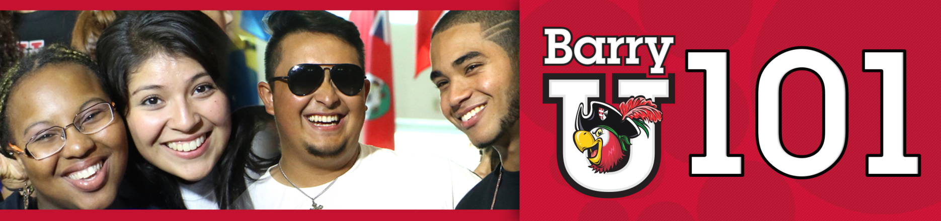
Freshmen Schedule
*The New Student BarryU 101Schedule may be subject to change

June 30th, 2016
7:00am - 8:30am BarryU 101 Check-In for all New Students HSC Gym

7:00am - 9:00am Time to Eat! Breakfast Roussell Dining Hall
8:00am Follow the leader & BarryU 101 Overview Broad Auditorium
Meet your BarryU 101 Leaders and get a brief overview of what the day brings

8:30am Campus Resources Panel Broad Auditorium

9:00am Welcome! Bienvenidos! Bienveni! Broad Auditorium

9:30am ORI 100 Broad Auditorium

10:00am Money Matters$$$!!! Broad Auditorium
(Financial Aid & Cashier/Business Office)

11:00am Information Technology Garner Classroom (TBA)

12:00pm Time to Eat! Lunch Roussell Dining Hall

1:30pm All about Academics! Academic ABC’s Broad Auditorium

2:00pm Find Your Niche! School and Major Meetings:
Arts & Sciences Broad Auditorium
Human Performance & Leisure Sciences HSC 1
Health Sciences SNHS 222
Nursing Weigand 116W
Business Andreas 110
Education Powers 143 C
Social Work Powers 106

2:30pm – 6:00pm Tests? Already? Early Challenge/ Placement Testing Library Classroom 144

2:30pm-6:00pm Learn the Ropes… Academic Advising Various Locations

2:30pm-6:00pm Get it Done! Registration for Classes Andreas 111

2:30pm-6:00pm Feedback! BarryU 101Survey & Snacks Andreas 112

5:00pm Time to Eat! Dinner Roussell Dining Hall

6:00pm Residence Life Meeting Thompson 230
(Mandatory for those living on campus)
Drive Time Show - Commuter Meeting Library
(For Commuters Only)

7:00pm - 10:00pm Pool Party Penafort Pool

July 1st, 2016
7:00am – 9:00am Time to Eat! Breakfast Roussell Dining Hall
8:30am – 12:00pm Tests? Already? Early Challenge/ Placement Testing Library 144

9:00pm-12:00pm Learn the Ropes… Academic Advising Various Locations

8:30am -12:00pm Get it Done! Registration for Classes Andreas 111
10:30am-1:00pm Feedback! BarryU 101Survey & Snacks Andreas 112
(Candy & Popcorn Bar)

1:00pm – 5:00pm Check-Out …Return Room Keys & Meal Cards D&D and Weber Hall (Front Desk)

