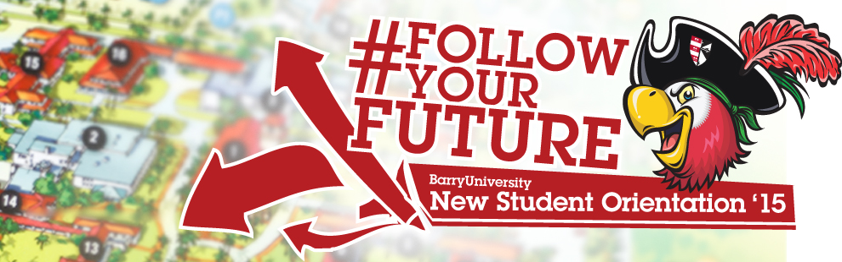
Family & Guests Schedule - Freshmen
June 29th& 30th

Day One: June 29th, 2015

7:00am-8:00am Orientation Check-In for all Family& Guests HSC Gymnasium
7:00am-9:00am Campus Connections & Resources Fair HSC Gymnasium
(includes continental Breakfast)

7:00am-9:00am Financial Questions? HSC Gymnasium
(7:00am-9:00am)
Financial Aid/ Business Office Available
8:00am-4:00pm Hospitality Lounge (Refresh & Recharge) Commuter Lounge
Coffee, Tea, Light Snacks, Phone/ Eletronic Charging Stations, (Landon 109)
Resourses, and Newspaper
8:00am Meet Your Orientation Leader! Landon Events Room
8:30am Orientation Overview Landon Events Room
9:00am Welcome! Bienvenidos! Bienveni! Broad Auditorium

9:30am What is BU? The Mission Broad Auditorium
10:00am-11:00am Campus Resources Panel Landon Events Room
11:00am-11:30am Student Resource Panel Landon Events Room
11:30am- 12:00pm Learning Center & Academic Resources Landon Events Room
12:00pm-12:45pm Time to Eat! Lunch Bucky’s Cove
12:45pm-1:30pm Student Life Landon Events Room
(Vice President of Student Affairs & Dean of Students)
1:30pm – 2:30pm Money Matters$$!!! Landon Events Room
2:30pm -3:30pm I’m First – First Generation College Student Landon Events Room
3:30pm-5:00pm Campus Tours Landon 109 (Tours pick-up from Commuter Lounge)
3:30pm-5:00pm Feedback! Orientation Survey & Snacks Andreas 112
(Candy & Popcorn Bar)
6:00pm – 7:00pm Time to Eat! Dinner Bucky’s Cove
(Landon Courtyard)
7:00pm – 8:00pm Parent Dessert Reception Landon Events Room

Day One: June 30th, 2015

6:30am – 9:00am Time to Eat! Breakfast HSC Gymnasium
9:00am-4:00pm Hospitality Lounge (Refresh & Recharge) Commuter Lounge
Coffee, Tea, Light Snacks, Phone/ Eletronic Charging Stations, (Landon 109)
Resourses, and Newspaper
8:30am – 5:00pm Financial Questions? Andreas 111
Financial Aid/ Business Office Available
9:00am Follow the Leader! Meet w/ Orientation Leaders Various Locations
9:30am ORI 100 Presentation Broad Auditorium
10:00am Learning Communities Broad Auditorium
11:00am All About Academics! Academics ABC’s Broad Auditorium
11:30am Find Your Niche! School and Major Meetings:
Arts & Sciences Broad Auditorium
Human Performance & Leisure HSC 1
Health Sciences SNHS 222
Nursing Weigand 116E
Business Andreas 110
Education Powers 143 C
Social Work Powers 106

12:00pm – 2:00pm Time to Eat! Lunch HSC Gymnasium

1:00pm-4:00pm Campus Tours Landon 109
(Tours Pick-up from the Commuter Lounge)

1:00pm-5:00pm Feedback! Orientation Survey & Snacks Andreas 112
(Candy & Popcorn Bar)
2:00pm – 5:00pm Check-Out …Return Room Keys & Meal Cards D&D and Weber Hall (Front Desk)

