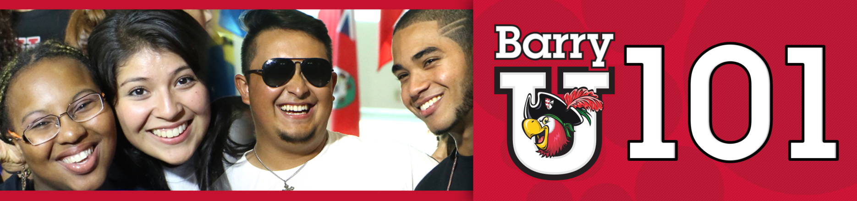
Freshmen/ Transfer Student Schedule
*The New Student BarryU 101Schedule maybe subject to change

Monday, July 11th, 2016

7:00am - 8:30am BarryU 101 Check-In for all New Students HCS Gym

7:00am - 9:00am Time to Eat! Breakfast Roussell Dining Hall
8:00am Follow the Leader & BarryU 101 Overview Broad Auditorium
Meet your BarryU 101Leaders and get a brief overview of what the day brings

8:30am Campus Resource Panel Broad Auditorium

9:00am Welcome! Bienvenidos! Bienveni! Broad Auditorium

9:30am ORI 100 (Freshmen Only) Broad Auditorium

9:30am Career Connections (Transfers Only) Thompson 230

10:00am Money Matters$$$!!! Broad Auditorium
(Financial Aid & Cashier/Business Office)

11:00am Information Technology Garner Classroom (TBA)

12:00pm Time to Eat! Lunch Roussell Dining Hall

1:30pm All about Academics! Academic ABC’s Broad Auditorium

2:00pm Find Your Niche! School and Major Meetings:
Arts & Sciences Broad Auditorium
Human Performance & Leisure Sciences HSC 1
Health Sciences SNHS 222
Nursing Weigand 116W
Business Andreas 110
Education Powers 143 C
Social Work Powers 106

2:30pm – 6:00pm Tests? Already? Early Challenge/ Placement Testing Library Classroom 144

2:30pm-6:00pm Learn the Ropes… Academic Advising Various Locations

2:30pm-6:00pm Get it Done! Registration for Classes Andreas 111

2:30pm-6:00pm Feedback! BarryU 101 Survey & Snacks Andreas 112

6:00pm Residence Life Meeting Thompson 230
(Mandatory for those living on campus)

Drive Time Show - Commuter Meeting Library
(For Commuters Only)

