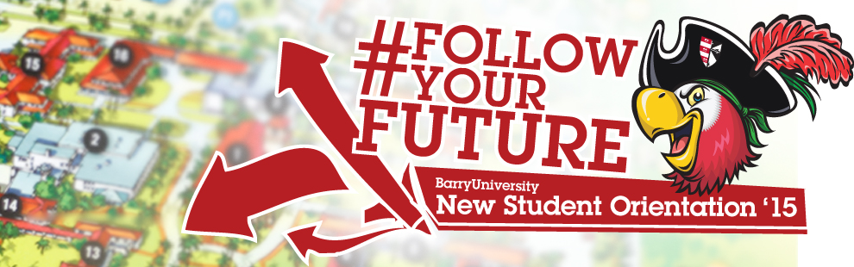
New Student Orientation – Transfer Schedule
June 29rd, 2015
*The New Student Orientation Schedule may be subject to change

7:00am-8:30am Orientation Check-In for all New Students HSC Gymnasium
*Continental Breakfast
*Check-in to Residence Hall Rooms if staying on Campus

7:00am – 9:00am Campus Connections & Resources Fair HSC Gymnasium
(includes continental Breakfast)

7:00am-6:00pm Financial Questions? HSC Gymnasium
(7:00am-9:00am)
Financial Aid & Cashier/ Business Office Available Andreas 111
(2:00pm-6:00pm)
7:00am-9:00am Tests? Already? Early Challenge/ Placement Testing Library Classroom 144
8:00am Orientation Overview Various Locations

8:30am Drive Time Show - Commuter Meeting Broad Auditorium

9:00am Welcome! Bienvenidos! Bienveni! Broad Auditorium

9:30am What is BU? The Mission Broad Auditorium
10:00am - 11:00am Money Matters$$$!!! Thompson 230
Financial Aid/ Business Services
11:00am – 12:00pm - Career Connections! Get eBUC$ Thompson 230

12:00pm – 1:00pm Time to Eat! Lunch HSC Gymnasium
1:00pm – 2:00pm Information Technology Garner (TBD)
2:00pm All about Academics! Academic ABC’s Broad Auditorium
2:30pm Find Your Niche! School and Major Meetings:
Arts & Sciences Broad Auditorium
Human Performance & Leisure HSC 1
Health Sciences SNHS 222
Nursing Weigand 116E
Business Andreas 110
Education Powers 143 C
Social Work Powers 106

3:00pm- 5:00pm Tests? Already? Early Challenge/ Placement Testing Library Classroom 144
(Pick up Challenge and Placement Test Results)
3:00pm-5:30pm Learn the Ropes… Academic Advising Various Locations

3:00pm-6:00pm Get it Done! Registration for Classes Andreas 111

3:00pm-5:00pm Feedback! Orientation Survey & Snacks Andreas 112
(Candy & Popcorn Bar)

3:00pm-5:00pm Campus Tours Leaving from Landon 109
(*registration must be completed prior to taking a tour)

4:00pm New Athletes Meeting Landon Events Room
5:00pm Housing and Residence Life Meeting Broad Auditorium
(mandatory for all students living on-campus)

3:00am – 5:00pm Check-Out …Return Room Keys & Meal Cards D&D or Weber Hall (Front Desk)

