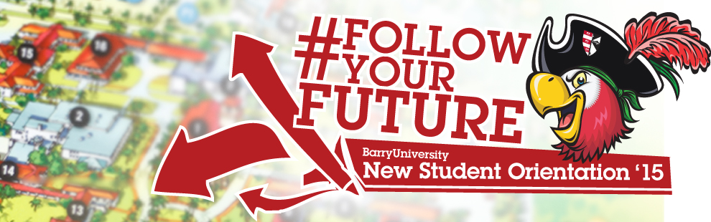
Family & Guests Schedule - Transfer Orientation
June 29th, 2015

7:00am-8:00am Orientation Check-In for all Family & Guests HSC Gymnasium
7:00am-9:00am Campus Connections & Resources Fair HSC Gymnasium
(includes continental breakfast)

7:00am-6:00pm Financial Questions? HSC Gymnasium
(7:00am-9:00am)
Financial Aid & Cashier/ Business Office Andreas 111
(2:00pm-6:00pm)
8:00am-4:00pm Hospitality Lounge (Refresh & Recharge) Commuter Lounge
Coffee, Tea, Light Snacks, Phone/ Electronic Charging Stations, (Landon 109)
Resources, and Newspaper
8:00am Meet Your Orientation Leader! Landon Events Room

8:30am Orientation Overview Landon Events Room
9:00am Welcome! Bienvenidos! Bienveni! Broad Auditorium

9:30am What is BU? The Mission Broad Auditorium
10:00am-11:00am Campus Resources Panel Landon Events Room
11:00am-11:30am Student Resource Panel Landon Events Room
11:30am- 12:00pm Learning Center & Academic Resources Landon Events Room
12:00pm-12:45pm Time to Eat! Lunch Buc Stop
12:45pm-1:30pm Student Life Landon Events Room
(Vice President of Student Affairs & Dean of Students)
1:30pm – 2:30pm Money Matters$$!!! Landon Events Room
2:30pm Find Your Niche! School and Major Meetings:
Arts & Sciences Broad Auditorium
Human Performance & Leisure HSC 1
Health Sciences SNHS 222
Nursing Weigand 116E
Business Andreas 110
Education Powers 143 C
Social Work Powers 106

3:00pm-5:00pm Campus Tours Landon 109 (Tours pick-up from Commuter Lounge)
3:00pm-5:00pm Feedback! Orientation Survey & Snacks Andreas 112
(Candy & Popcorn Bar)
3:00pm – 5:00pm Check-Out …Return Room Keys & Meal Cards D&D and Weber Hall (Front Desk)
6:00pm – 7:00pm Time to Eat! Dinner Bucky’s Cove
(Landon Courtyard)
7:00pm – 8:00pm Parent Dessert Reception Bucky’s Cove

