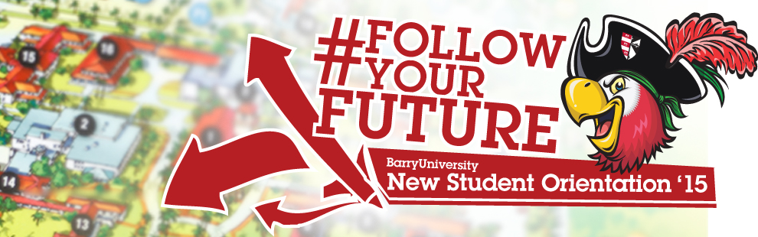
New Student Orientation – Freshmen Schedule
*The New Student Orientation Schedule may be subject to change

Wednesday, August 19th, 2015:

10:00am-4:00pm Move-in (All Freshmen/ Transfer Resident Students) Landon Student Union
Orientation Check-In (Bucky’s Cove/Landon Events Room)

11:00am-2:00pm Campus Tours (Optional) Depart from Landon 109 *Designated Times: 11:00am, 12:00pm, 1:00pm & 2:00pm

12:00pm – 4:00pm Resource Fair! HSC Gymnasium

1:00pm-5:00pm Publix & Target Trips (Optional) Landon Atrium *Designated Times: 1:00pm, 2:00pm, 3:00pm & 4:00pm

Walmart Trips (Optional) Landon Atrium
*Designated Times: 1:00pm, 2:30pm, & 4:00pm

4:30pm Housing & Residence Life Meeting Broad Auditorium
* Mandatory for all students living on campus

5:00pm Hall Meetings Various Locations
* Mandatory for all students living on campus

6:00pm – 6:45pm Time to Eat! Dinner Dominican Lawn

6:45pm Speed Meeting & Ice Cream Social! Dominican Hall Field
7:00pm Pre-Game Bash!! Soccer Field
(Women’s Soccer Game vs. Johnson & Wales)
Thursday, August 20th, 2015:

6:00am-8:30am Orientation Check-In for all New Students HSC Gymnasium
*Continental Breakfast
* Only for students who have not checked in yet

6:30am Follow the Leader! Meet your Orientation Leaders Various Locations
*Only for students who are required to take placement testing

7:00am – 9:00am Campus Connections & Resources Fair HSC Gymnasium

7:00am-6:00pm Financial Questions? HSC Gymnasium
(7:00am-9:00am)
Financial Aid & Cashier / Business Office Andreas 111
(2:00pm-6:00pm)
7:00am-9:00am Tests? Already? Early Challenge/ Placement Testing Library Classroom 144
8:00am Follow the Leader! Meet your Orientation Leaders Various Locations and go through the Orientation Overview
*Only for students who are NOT required to take placement testing

8:30am Commuter Drive Time Show Thompson 230

9:00am Welcome! Bienvenidos! Bienveni! Broad Auditorium

9:30am What is BU? The Mission Broad Auditorium
10:00am – 11:00am Decisions, Decisions! (Making Good Choices) Broad Auditorium
11:00am – 11:30am Campus Resource Panel Broad Auditorium
11:30am – 12:00pm First Year Experience Programs Broad Auditorium

12:00pm – 1:00pm Time to Eat! Lunch Roussell Dining Hall

1:00pm – 2:30pm Information Technology Garner TBA
2:30pm – 3:00pm Learning Center Resources Gato Gallery
3:00pm – 4:00pm Money Matters$$$!!! Gato Gallery Financial Aid & Cashier / Business Office
4:00pm – 5:00pm Orientation Leader Time! Various Locations
5:00pm New Athletes Meeting Landon Events Room
(For Athletes Only)
5:00pm – 7:00pm Soup’s On! Dinner Roussell Dining Hall

6:30pm – 10:00pm Miami Bus Tour Various Miami Locations
*Spaces are limited sign-up at the
Hospitality Desk / Commuter Lounge
Stopping at Bayside and Lincoln Road (South Beach)

9:00pm – 11:00pm Movie & Pizza Social Landon Events Room
Friday, August 21st, 2015:

6:30am – 9:00am Time to Eat! Breakfast Roussell Dining Hall
6:30am Follow the Leader! Meet your Orientation Leaders Various Locations
*Only for students who are required to take placement testing

7:00am – 9:00am Tests? Already? Challenge/Placement Testing Library Classroom 144
8:30am Follow the Leader! Meet w/ Orientation Leaders Various Locations
9:00am ORI 100 Presentation Broad Auditorium
9:30am All About Academics! Academic ABC’s Broad Auditorium
10:00am Find Your Niche! School and Major Meetings:
Arts & Sciences Broad Auditorium
Human Performance & Leisure HSC 1
Health Sciences SNHS 222
Nursing Weigand 249
Business Andreas 110
Education Powers 143 C
Social Work Powers 106
10:30am - 3:00pm Tests? Already? Early Challenge/ Placement Testing Library Classroom 144
(Pick up Challenge and Placement Test Results)
10:30am - 3:00pm Learn the Ropes… Academic Advising Various Locations

10:30am – 5:00pm Financial Questions? Andreas 111
Financial Aid & Cashier / Business Office
11:00am-4:00pm Get it Done! Registration for Classes Andreas 111

12:00pm – 2:00pm Time to Eat! Lunch Roussell Dining Hall

12:00pm-4:00pm Feedback! Orientation Survey & Snacks Andreas 112
(Candy & Popcorn Bar)

3:30pm Dean of Students Meeting Broad Auditorium
*Mandatory Program

4:00pm The Hook Up: Broad Auditorium
When It’s Hot and When It’s Not
*Mandatory Program

5:30pm – 7:00pm Time to Eat! Dinner Roussell Dining Hall

7:00pm - 10:00pm Late Night Gaming TBA
(Laser Tag & Novelties)

