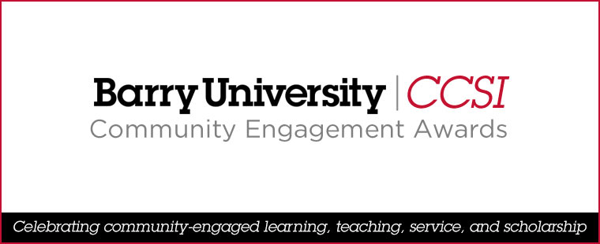

NOMINATION FORM: Community Partnership Award

Nomination Deadline: Friday, January 26, 2024

Nominee (Organization):
Contact Person’s Name: |  | Contact Person’s Title:
Contact Person’s Email Address: |  | Contact Person’s Phone Number:
Nominator: |  | Nominator’s Email Address:
Statement (1,000–1,200 words) describing how the nominee has met the criteria for the award:

Supporting Documents: | Profile of organization (approx. 200 words) |  | Two letters of support* | Other documents
 | *One letter must be from a student, the other from a faculty or staff member.
 | Please submit by Friday, January 26, 2024, via email—with “Community Engagement Award Nomination” in the subject line—to <gbowen@barry.edu>.

