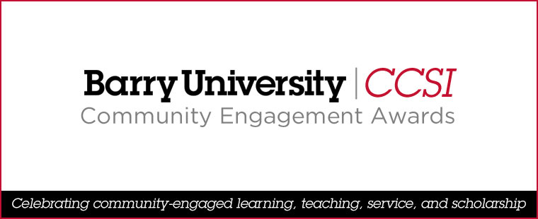

NOMINATION FORM: Engaged Department Award

Nomination Deadline: Friday, January 26, 2024

Nominee (Department):
Department Chair: |  | Email Address: |  | Phone Number:
Nominator: |  | Email Address: |  | Phone Number:
Statement (1,000–1,200 words) describing how the nominee has met the criteria for the award:

Supporting Documents: | Profile of Department (approx. 300 words) |  | Other documents
 | * News clippings, articles, photos, brochures, testimonials, etc.
 | Please submit by Friday, January 26, 2024, via email—with “Community Engagement Award Nomination” in the subject line—to <gbowen@barry.edu>.

