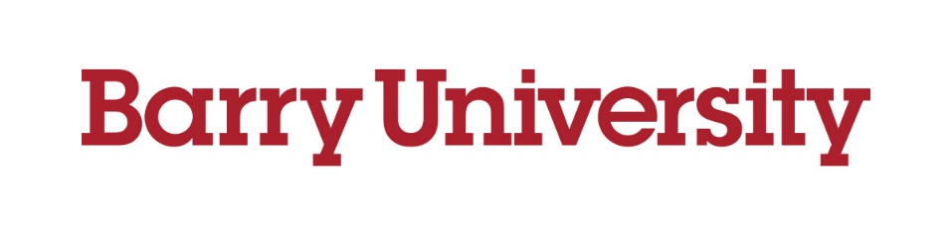  Center for Community Service Initiatives  COMMUNITY ENGAGEMENT SYMPOSIUM  March 29, 2023  Cultivating Campus–Community Collaboration  for Collective Impact | PROPOSAL  FOR  PRESENTATION

Submission deadline: Friday, January 27

Lead Presenter: | Co-presenter (if applicable):
Institution/Organization: | Co-presenter (if applicable):
Position/Job Title: | Co-presenter (if applicable):
Email Address: | Co-presenter (if applicable):
Presentation Title:
Presenters’ Brief Bios (maximum 50 words for each bio):

Peer reviewers will evaluate all proposals based on partnership,
community impact, participant engagement, and abstract.

Community Engagement Symposium

PROPOSAL FOR PRESENTATION

Presentation Title:
Presentation Format (Please check one box only—click to check box):
Audiovisual presentation (50 minutes) Audiovisual presentation by students only (20 minutes)
Panel discussion (50 minutes)
Community Partner(s) for Course, Program, or Project:

Community Impact of Course, Program, or Project (75 words max.):

Participant Engagement Techniques (20 words max.):

Abstract (approx. 80 words, mentioning the course, program, or project; indicating either the community impact or the nature of the impact; and highlighting other key elements of the presentation):

Please submit your proposal (in Microsoft Word) by Friday, January 27, 2023 via email
—with “Symposium Presentation Proposal” in the subject line—to qep@barry.edu.

