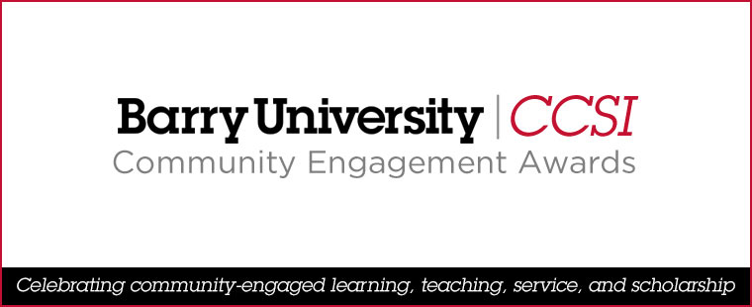

NOMINATION FORM: Community Engagement Educator Award

Nomination Deadline: Friday, January 26, 2024

Nominee:
Job Title: |  | Department:
Email Address: |  | Phone Number:
Nominator: |  | Nominator’s Email Address:
Statement (400–600 words) describing how the nominee has met the criteria for the award:

Supporting Documents: | Nominee’s CV | Three letters of support* | Other documents
 | *One each from a student, faculty/staff member, and community partner.
 | Please submit by Friday, January 26, 2024, via email—with “Community Engagement Award Nomination” in the subject line—to <gbowen@barry.edu>.

